**Genome-Wide DNA Methylation Profiles of Low- and High-Grade Adenoma Reveals Potential Biomarkers for Early Diagnosis of Colorectal Carcinoma**

Jian Fan Ph.D1,4 #, Jun Li M.D2 #, Shicheng Guo Ph.D3 # ,Chengcheng Tao B.A1, Haikun Zhang Ph.D1,4, Wenjing Wang M.D2, Ying Zhang B.A1, Dake Zhang Ph.D1\*, Shigang Ding M.D2\*, Changqing Zeng Ph.D1\*.

1，Key Laboratory of Genomic and Precision Medicine, Beijing Institute of Genomics, Chinese Academy of Sciences, Beijing 100101, China

2，Department of Gastroenterology, Peking University Third Hospital, Beijing 100191, China

3，Center for Precision Medicine Research, Marshfield Clinic Research Institute, Marshfield, WI 54449, USA

4，University of Chinese Academy of Sciences, Beijing 100049, China

# These authors contributed equally to this work; \* Corresponding Author

**Information for Corresponding Author:**

Changqing Zeng, Ph.D. Email: [czeng@big.ac.cn](mailto:czeng@big.ac.cn);

Shigang Ding, M.D. Email: [dingshigang222@163.com](mailto:dingshigang222@163.com)

Dake Zhang, Ph.D. Email: [dakezhang@gmail.com](mailto:dakezhang@gmail.com)

**Word Count (text only): 4739**

**Guarantor of the Article:** Changqing Zeng, Ph.D. Email: czeng@big.ac.cn

**Specific Author Contributions:** JF developed the analysis method and drafted the manuscript. JL recruited patients, provided clinical expertise on colorectal adenomas, and interpreted the results. JF, HZ, and SG performed data analysis. SG, DZ reviewed and edited the manuscript and provided respective scientific expertise in result interpretation. CT and YZ conducted array experiments. WW collected and prepared tissue samples and collected the results of clinical assays. SD funded and supervised all clinical procedures for enrolled patients. DZ and CZ designed the study, supervised all experiments and analysis, provided molecular and cellular biology advice, and reviewed and edited the manuscript.

**Financial Support:** This study is funded by Innovation Promotion Association CAS (2016098), Major State Basic Research Development Program (2014CB542006), Key Research Program of the Chinese Academy of Sciences (KJZD-EW-L14), and National Key Research and Development Plan of China (2016YFA0201404).

**Potential Competing Interests:** the authors disclose no potential competing interests.

**Data Access:** DNA methylation data and scripts are available upon request. Other data involved in this study included GSE68060, GSE68838, GSE77954, GSE77965, GSE81211, GSE101764, GSE107352, GSE75546, and E-MTAB-6450.

**Acknowledgements:** The authors gratefully acknowledge Dr. Steven J Schrodi, Dr. Emily A. Andreae and Dr. Ingrid Glurich from Center for Precision Medicine Research (CPMR), Marshfield Clinic Research Institute (MCRI) for reviewing, commenting and editing their manuscript.

**STUDY HIGHLIGHTS**

WHAT IS KNOWN

* DNA methylation is a promising biomarker for cancer diagnosis and surveillance
* Adenoma samples are perfect proxy for colorectal carcinoma early biomarker identification

WHAT IS NEW HERE

* DNA methylation landscape of adenoma was established for early biomarker identification
* ADHFE1 is a potential early diagnosis biomarker of colorectal carcinoma and adenoma
* Nervous system related methylation changes significantly associated with colorectal carcinoma development

## **Abstract**

**Objectives:** Abnormal DNA methylation is a hallmark of human cancers and may be a promising biomarker for early diagnosis of human cancers1. However, the majority of DNA methylation biomarkers that have been identified are based on the hypothesis that early differential methylation regions (DMRs) are maintained throughout carcinogenesis and could be detected at all stages of cancer.

**Methods:** In this study, we identified potential early biomarkers of colorectal cancer (CRC) development by genome-wide DNA methylation assay (Illumina infinium450, 450K) to normal (N=20) and pre-colorectal cancer samples including 18 low-grade adenoma (LGA) and 22 high-grade adenoma (HGA).

**Results:** We identified 209 and 8,692 CpG sites that were significantly hyper-methylated in low-grade adenoma and high-grade adenoma, respectively. Pathway analysis identified nervous system-related methylation changes that are significantly associated with early adenoma development. Together with GEO and ArrayExpress datasets (N=833), integration analysis revealed that DNA methylation in the promoter region of *ADHFE1* has the most potential for being an early diagnostic biomarker for colorectal adenoma and cancer (sensitivity=0.96, specificity=0.95, area under the curve=0.97).

**Conclusions:** Overall, we demonstrated LGA and HGA provided an important proxy for early methylation biomarker identification and *ADHFE1* could be a promising methylation biomarker for colorectal cancer.

**Key words:**

DNA methylation, Low-grade adenoma, High-grade adenoma, Colorectal cancer, Biomarker

## **Abbreviations**

LGA: Low-grade adenoma

HGA: High-grade adenoma

DMR: Different methylation region

DMS: Different methylation site

ROC: Receiver operating characteristic

AUC: Area under the curve

IPA: Ingenuity Pathway Analysis

KEGG: Kyoto Encyclopedia of Genes and Genomes

GO: Gene Ontology

t-SNE: t-distributed stochastic neighbor embedding

PCA: Principal components analysis

mBV: Mean beta values

FDR: False discovery rate

SNP: Single nucleotide polymorphism

UTR5: 5′ untranslated region

CHR: Chromosome

## **Background**

Colorectal cancer (CRC) is the third leading cause of cancer-related deaths worldwide 2,3. Current evidence indicates that genetic mutations and epigenetic alterations are progressively accumulated in the tumor genome during carcinogenesis, and these alterations may serve as primary biomarkers for early detection and treatment of cancer4. Abnormal alterations in methylation status specifically hyper-methylation or hypo-methylation in the promoter regions of tumor suppressor genes and miRNA have been observed in almost all cancer types 5,6. Over the past decades, DNA methylation has been widely studied to develop cancer biomarkers 7 and has been used as an indicator of disease progression such as hepatitis, cirrhosis, and hepatocellular carcinoma (HCC) 8,9. Moreover, recent evidence shows that cell-free DNA (cfDNA) methylation can be used for early cancer diagnosis and tissue-of-origin mapping for metastatic cancer 5.

Abnormal alterations of DNA methylation have been recognized as an important event in cancer development. Global hypo-methylation arises early in carcinogenesis and has been linked to chromosomal instability and loss of imprinting 10,11. Generally during cancer development, hundreds of genes are [silenced or activated](https://en.wikipedia.org/wiki/Regulation_of_transcription_in_cancer#Transcription_silencing/activation_in_cancers) 12-14. Although silencing of some genes in cancers occurs by mutation, a large proportion of carcinogenic gene silencing is a result of altered DNA methylation15. DNA methylation-based silencing in cancer typically occurs at multiple CpG sites in the [CpG islands](https://en.wikipedia.org/wiki/CpG_site" \l "CpG_island" \o "CpG site)  present in the promoters of protein-coding genes 16. On this background of whole genome hypo-methylation, gene-specific promoter hyper-methylation has been found to promote CRC by down-regulating the expression of key tumor suppressor genes such as *CDKN2A*, *MLH1*, and *CDH1* 17-19. Although extensive epigenetic alterations have been illustrated over the past years, CRC is still not well understood at the molecular level4. CRC is a heterogeneous disease that typically starts from a [benign tumor](https://en.wikipedia.org/wiki/Adenoma) which is often in the form of an adenoma and becomes a malignant cancer over a period of 10 or more years 20. Early identification and resection of benign colorectal tumors at the colorectal adenoma (CA) stage provides an excellent opportunity to prevent CRC cancerization and increase patient survival21. Colorectal adenoma is subdivided into two different pathologic subtypes based on likelihood of cancer progression specifically low-grade adenoma (LGA) and high-grade adenoma (HGA)22. Molecular alterations in LGA could serve as potential early diagnostic biomarkers for CRC development though to the best of our knowledge, no group has identified and compared the differences in whole-genome DNA methylation patterns between these two subtypes 23. A comprehensive understanding of the alterations in genome-wide DNA methylation profile for early stage pre-cancerous lesions (LGA and HGA) may provide an important resources for candidate biomarkers for early diagnosis of cancer.

In this study, we conducted a series of genome-wide DNA methylation array of 18 LGA and 22 HGA and compared the frequency, location, and pattern of methylation status to 20 normal tissue samples. Dynamic changes in DNA methylation patterns between LGA and HGA were identified, and we found that methylation changes appeared in LGA were increased or maintained in HGA and cancer. Enrichment analyses of differential methylation regions (DMRs) were performed to further classify potential DNA methylation that may influence functional differences in adenoma initiation and development. Moreover, we separated different methylation sites (DMSs) between LGA and normal into hyper-DMS and hypo-DMS and evaluated their respective performance for CA and CRC prediction. To validate our findings, we compared them to genome-wide DNA methylation profiles of 833 samples from public database. Finally, we describe the identification and analysis of one functional methylation signature at the promotor region of *ADHFE1* as a potential biomarker for early CRC development.

## **Methods**

**Sample collection and pathological confirmation**

In the Department of Gastroenterology of Peking University Third hospital from March 2015 to June 2016, we collected 18 LGA specimens, and 22 HGA specimens from patients who underwent endoscopic treatment for CA removal, and obtained adjacent normal tissue specimens from 20 patients with adenoma during the treatment. The study protocol conformed to the ethical guidelines of the 1975 Declaration of Helsinki and was approved by the Ethics Committee of Peking University Third hospital (IRB number: 206H005). Informed written consent was obtained from all patients and volunteers prior to the procedure. Tissue specimens were embedded in paraffin, sectioned, stained with hematoxylin and eosin, and confirmed by pathologist by light microscopy. Sample information and loading quantity are provided on **Table S1.**

**DNA isolation and bisulfite conversion**

DNA was isolated using QIAmp DNA Mini Kit (Qiagen, Hilden, Germany) according to manufacturer’s protocol. Bisulfite conversion was performed using the EZ DNA Methylation-Gold Kit according to the instruction manual (Zymo Research, Irvine, CA, USA).

**Methylation data processing**

Epigenome-wide DNA methylation assessment for this study was performed using the Illumina Infinium Human Methylation 450 BeadChip (Illumina, San Diego, CA, USA), which simultaneously profiles the methylation status for >485,000 CpG sites at single-nucleotide resolution and covers 96% of CpG islands with additional coverage of island shores (<2 Kb from CpG Islands), island shelves (2–4 Kb from CpG islands), and regions flanking them. The methylation status for each CpG site was calculated as the ratio of fluorescent signals (β = Max(M,0)/[Max(M,0) + Max(U,0) + 100]), ranging from 0 to 1 using the average probe intensity for the methylated (M) and unmethylated (U) alleles. β= 1 indicates complete methylation; β = 0 represents no methylation. The raw data from the array was processed using The GenomeStudio Methylation (version 1.8, Illumina) module which calculated methylation levels; normalization was performed by set parameters as controls, and background adjustment was performed automatically by the software selecting Subtract Background. Probes located on sex chromosomes or failed detection P value testing of at least one sample or SNP (single nucleotide polymorphism), were removed from analysis using R package IMA (vision 3.1.2)24. DMRs were defined as rank sum test following false discovery rate (FDR) adjusted P value<0.05 and |β|>0.15, and DMSs were defined as rank sum test following FDR adjusted P value<0.05 and |β|>0.20. Promoter regions were defined as 5′UTR, TSS200, TSS1500 and first exons.

**Public data collection and processing**

To ensure consistency of data processing, we only compared our samples with publically accessible samples with raw *idat* files. GSE68060, GSE68838, GSE77954, GSE77965, GSE81211, GSE101764, GSE107352 and GSE75546 were collected from GEO while E-MTAB-6450 was collected from ArrayExpress 25-30 (**Table S2**). Some cell line samples and metastatic cancer samples were removed upon further study. In total, we collected 278 normal samples, 51 adenoma samples, and 504 cancer samples. All datasets using raw *idat* files were preprocessed using R package minfi (vision 1.28.4) 31. The sites which failed detection at P = 0.01 were rewrote by nearest neighbor average to ensure an adequate number of sites for analysis.

**Comparison of the ability of discrimination between normal, LGA, HGA, and CRC tissue**

For random forest prediction, we used R package randomForest (vision 4.6.14) with the number of trees set at 5,00032. For neural network prediction, we used R package nnet (vision 7.3.12) with number of units in the hidden layer as 2, weight decay as 10-4, and with a maximum number of iterations at 40033. The R package pROC (vision 1.14.0) was used for ROC analysis to compare the abilities of various models to distinguish between hyper- and hypo-methlyated sites by the area under the curve (AUC) analyis34.

**t-SNE analysis, PCA analysis and Gene Enrichment analysis**

tSNE analysis was performed by R package tsne (vision 0.1-3)35. PCA was performed by R function princomp and visualized by first two principal components. KEGG and GO enrichment were analyzed online by DAVID 6.8 (<https://david.ncifcrf.gov>)36,37. Ingenuity Pathway Analysis (IPA) was also used for enrichment analysis for more elaborate results with the P-value cutoff set at 0.0538.

## **Results**

#### Landscape of DNA methylation of pre-cancerous benign lesions

We profiled DNA methylation at the single-base level for 18 LGA, 22 HGA, and 20 normal tissues. We found significant genome-wide DNA methylation differences among normal, low-, and high-grade adenoma (**Figure 1A** and **1B**). Compared to normal tissue, LGA had genome wide hypo-methylation (P = 5.2x10-5, rank sum test) which was even lower in HGA (P = 3.7x10-6, compared with normal, rank sum test, **Figure 1C**). Methylation levels of all target sites in the array demonstrated the known bimodal distribution in normal, LGA, and HGA (**Figure 1D**), and the amount of fully methylated sites of lesions decreased with increasing degree of malignancy (right peak, **Figure 1D**; **Figure 1E**). Almost all DMSs in LGA compared to normal tissues kept at least an equivalent methylation level if not higher than in HGA and cancer. The 209 significantly hyper-methylated sites in LGA were further hyper-methylated in 22 HGA compared to 504 cancer samples collected from public databases (**Figure 1F**), and hypo-DMSs had a diametric tendency (**Figure S1**) suggesting that DNA demethylation may occur very early in precancerous lesions. Over 60% of DMRs that were observed in both LGA (71.4%, 314/440) and HGA (61.9%, 4,213/6,805) were hypo-methylated compared to normal tissues (**Figure 1G, Table S1-2**). However, with LGA as the reference, most DMRs observed in HGA were hyper-methylated (76.0%, 660/868) (**Figure 1G, Table S3**). In addition, there were limited overlaps between genes with DMRs in LGA compared to normal tissues and those compared to HGA hinting at a different epigenetic process between LGA and HGA (**Figure 1H**)39.

#### Nervous system processes were associated with adenoma development

KEGG enrichment analysis of 603 DMRs between HGA and LGA indicated that the top enriched functional terms were nervous system and signal transduction associated (**Figure 2A**) specifically dopaminergic synapse and serotonergic synapse pathways, which play a role in the gut-brain axis model of signaling cross-talk between organ systems40. These results correspond to gene methylation findings in **Figure 1G** where HGA versus (vs) normal includes almost all genes that are listed in LGA vs Normal and LGA versus HGA DMRs. To figure out the potential function changes from LGA to HGA, Gene Ontology (GO) enrichment was performed for 275 genes that were significantly different in methylation status between LGA vs normal and HGA vs normal without considering the differences in methylation status between LGA vs HGA. 571 significantly different methylated genes were highlighted in LGA vs HGA and HGA vs normal without LGA VS Normal (**Figure 2B**). For the 275 genes with significantly different methylation patterns in only the LGA vs normal and HGA vs normal comparisons, GO analysis selected the top enriched terms of proteolysis as well as extracellular matrix disassembly, inorganic anion transport, and cobalamin metabolic processes. Cell adhesion, positive regulation of positive chemotaxis, and neuropeptide signaling pathway were term hits on the overlapping part between LGA vs normal and LGA vs HGA. Genes that were significantly different in methylation status between LGA and HGA were enriched for chemical synaptic transmission, transmission of nerve impulse, calcium ion transmembrane transport, and similar neural processing terms. Like the DMR enrichment analysis, terms related to the nervous system were selected yet exhibited different term patterns between LGA vs HGA compared to LGA vs normal.

**Hyper-methylated CpG sites exhibited better discriminatory performance between normal, pre-cancerous, and cancerous tissues than the hypo-methylated pattern for CRC**

To distinguish the discriminatory ability of DNA methylation patterns for normal tissue, CA, and CRC, we collected 833 genome-wide DNA methylation datasets from GEO and ArrayExpress, public datasets which included 278 normal tissue samples, 51 adenoma samples, and 504 cancer samples. We separated DMSs into two groups including hyper-DMSs and hypo-DMSs. We found both hyper-DMSs and hypo-DMSs could effectively distinguish methylation pattern differences between disease (adenoma and cancer) and normal samples (**Figure 3A** and **Figure 3B**). Meanwhile, we also conducted two machine learning-based predictions with the DMSs identified in our dataset and observed that hyper-methylated sites can better distinguish between normal samples and disease samples via random forest and neural network methods (**Table 1**). For hyper-methylated sites, the area under the curve (AUC) of receiver operating characteristic (ROC) curves were 0.91 and 0.85, respectively. For hypo-methylated sites, AUC of ROC curves were lower at 0.72 and 0.76, respectively (**Figure 3C** and **Figure 3D**). Unsupervised tSNE cluster analysis produced the same result (**Figure 3E** and **Figure 3F**). To avoid inconsistent results caused by unstable methylation based on single CpG sites, we compared the mean beta value (mBV) of these sites. We found that hyper-methylated mBVs were significantly different between normal tissue and CRC (P<2.2x10-16); however, there was no significant difference between the adenoma and cancer (P= 0.29, **Figure 3G**) in which the average mBV of the normal tissue, adenoma, and cancer are 0.22, 0.54, and 0.57, respectively. We observed similar results for hypo-methylation sites in which the average mBV of the normal tissue, adenoma, and cancer were 0.70, 0.44, and 0.50, respectively (**Figure 3G**). Finally, we found the AUC of ROC curves with hyper-mBV and hypo-mBV were 0.98 and 0.95, respectively. Permutation analysis based on a bootstrap strategy indicated that the model based on hyper-methylated sites had better discriminatory power than the model of hypo-methylated sites (P<2.2x10-8, **Figure 3H**).

#### The promoter of ADHFE1 may be a potential biomarker for colorectal adenoma and cancer

Next, we grouped the DMRs of normal tissue and LGA into hyper- and hypo-DMRs and performed enrichment analysis by Ingenuity Pathway Analysis (IPA). The top enriched functional term for hyper DMRs was ethanol degradation II (P=5.4x10-3) which was mostly contributed by methylation sites on two genes, *ADHFE1* and *ACSS3*, which can facilitate the conversion from ethanol to acetaldehyde and from acetic acid to acetyl-CoA, respectively (**Figure 4A**). The expression of both genes were down-regulated ing colonic and rectal cancer tissue compared with normal tissue (P<0.01), a result consistent with the DNA methylation changes between LGA and HGA (R2=-0.49 and -0.59, **Figure 4B** and **Figure 4C**). We found that the average methylation level of CpG sites located in CpG islands within the promoter regions of *ADHFE1* and *ACSS3* were significantly increased in cancer samples compared to normal samples (mBVs=0.2 and 0.18, respectively). We further analyzed the promoter region within the CpG island of the two genes to distinguish between normal and disease tissues. When setting the cutoff at 0.25 for the *ADHFE1* promoter, the minimal error rate was only 4.68% (39/833, **Figure 4D**); the heatmap of sites within the region reflected the same result (**Figure 4E**). ROC curve analysis of mBV of the *ADHFE1* promoter compared to the mBV for all 833 samples produced an AUC of 0.97 with specificity and sensitivity at 0.95 and 0.96 (**Figure 4F**). For cancer samples, an AUC as high as 0.98 was determined (**Figure S2**). For *ACSS3*, the minimal error rate of its promoter was 16.68% (139/833) with a cutoff set at 0.42 (**Figure 4G**) which performed inferiorly to *ADHFE1* in terms of discrimination power. Meanwhile, we also compared *ADHFE1* with *SEPT9*, an FDA-approved methylation-based biomarker for CRC screening. We determined that *ADHFE1* had a better prediction power than *SEPT9* (**Figure 5A**) 41. Furthermore, we observed *ADHFE1* to have a much better separation boundary compared to *SEPT9* (**Figure 5B**).

## **Discussion**

Whole-genome DNA hypo-methylation and hyper-methylation analysis of the promoter regions of cancer-related genes are regarded as a common method of characterizing diverse cancers42. In our study, we found that whole-genome DNA hypo-methylation may start at the benign adenoma stage (LGA) and lead to further hypo-methylation at HGA and CRC (**Figure 1C**). As many previous studies have reported, a bimodal distribution can characterize DNA methylation pattern, and we noted that a hyper-methylated peak can clearly reflect progressive hypo-methylation (**Figure 1D** and **Figure 1E**)43. We identified 440 and 6,805 DMRs in low- and hyper-grade adenoma respectively, and of these DMRs, 314(71.4%) in LGA and 4,213 (61.9%) in HGA were hypo-methylated compared to normal tissues. On the contrary, most DMRs (660/868, 76.0%) differences between HGA and LGA were hyper-methylated. Aside from a little overlap between HGA genes, significantly distinct DMRs were located between LGA vs normal and LGA vs HGA which indicates that LGA vs Normal and LGA vs HGA are possibly not the same process with a degree difference but two different epigenetic processes. These genome-wide demethylation patterns may indicate that though hypo-methylation dominates the carcinogenesis of CRC, hyper-methylation sites may contribute more to the distinct malignancy of these lesions.

To find functional differences between differing methylation patterns in normal, pre-cancerous, and cancerous tissues, enrichment analysis was applied to 603 genes with DMRs between HGA and LGA which determined that the most enriched terms were related to nervous system and signal transduction (**Figure 2A**). Our KEGG enrichment analysis further highlighted the significance of dopaminergic synapse and serotonergic synapse to CRC development. Serotonin (5-hydroxytryptamine, 5-HT) is popularized as a contributor to feelings of well-being and happiness though its actual biological function is complex and multifaceted with roles in modulating cognition, reward, learning, memory, and numerous physiological processes44. Brain 5-HT gets much more respect, and certainly more press and research, than the vastly larger store of 5-HT in the gut though both are important for physiological functions45. Dopamine (3,4-dihydroxyphenethylamine, DA) is an organic chemical of the catecholamine and phenethylamine families that functions both as a hormone and a neurotransmitter and plays several important roles in the brain and body46. In the brain, dopamine functions as a neurotransmitter to send signals to other nerve cells46. Outside the central nervous system, dopamine functions primarily as a local paracrine messenger46 to reduce gastrointestinal motility and protect the intestinal mucosa46. Our study suggests that the gut–brain-axis and related molecules may be important contributors to the development and progression of CRC even at the benign adenoma stage.

DNA methylation has always been considered as a potential biomarker for many diseases due to its tissue specificity and stability47. Here, we analyzed DNA methylation patterns as a mechanism to distinguish disease samples (including adenoma and cancer) from normal samples during CRC development. We identified 209 hyper-methylated sites and 441 hypo-methylated sites between LGA and normal samples and noted that both hyper- and hypo-methylated sites could effectively distinguish between normal and CRC tissues. Further validation with random forest and neural network analyses confirmed our observations. Specifically, AUCs of ROC curves for our prediction model using hyper-methylated sites were larger than those using hypo-methylated sites, despite the observation that hypo-methylated sites were more than twice the number of hyper-methylated ones. Since tumors are known to have whole-genome hypo-methylation, we speculate that gene hyper-methylation at several key sites and/or global hypo-methylation during early CA may be the driver events for CRC. To reduce bias caused by unstable methylation on single CpG sites, we compared mBV of these sites among tissue groups. We found that hyper-methylated mBVs were significantly different between normal tissue and cancers (P<2.2x10-16), while no significance was found between the adenoma and CRC (P= 0.288, **Figure 3G**). Permutation analysis based on bootstrap strategy suggest that the model based on hyper-methylated sites has better discrimination power than the model of hypo-methylated sites (P<2.2x10-8, **Figure 3H**) which may lend support to the theory that hyper-methylation at several key sites may trigger widespread hypo-methylation throughout the genome during cancer development.

Colorectal adenoma is considered the middle stage between normal status and cancer; therefore, our Our study focused on identifying and comparing the differences in DNA methylation patterns among normal, pre-cancerous, and cancerous colorectal tissues. IPA enrichment analysis of hyper-DMRs identified in very early stage cancers selected Ethanol degradation II as the top term for functional impact, and further GO and KEGG enrichment analyses indicated that *ADHFE1* and *ACSS3* genes also played a prominent role in CRC carcinogenesis. Intense early changes in DNA methylation patterns at the promotor region of these genes supports their potential use as adenoma biomarker. It is known that *ADHFE1* encodes for hydroxyacid-oxoacid transhydrogenase which is responsible for the oxidation of 4-hydroxybutyrate in mammalian tissues48. Some studies have also reported that the gene is associated with cell proliferation and differentiation48-50. In CRC tissue, *ADHFE1* is hyper-methylated in the promoter region corresponding to down-regulation of expression that may facilitate tumor growth 50. Our results suggest that the methylation level of the *ADHFE1* promoter is a potential biomarker for distinguishing adenoma from normal tissue in either traditional biopsy or liquid biopsy. Further efforts with a larger, more diverse sample population is needed to validate the predictive efficacy of this biomarker for CRC.

## **Reference**

1. Esteller M. Cancer epigenomics: DNA methylomes and histone-modification maps. *Nat Rev Genet.* 2007;8(4):286-298.

2. Siegel RL, Miller KD, Jemal A. Cancer statistics, 2018. *CA Cancer J Clin.* 2018;68(1):7-30.

3. Chen W, Zheng R, Baade PD, et al. Cancer statistics in China, 2015. *CA Cancer J Clin.* 2016;66(2):115-132.

4. Kuipers EJ, Grady WM, Lieberman D, et al. Colorectal cancer. *Nat Rev Dis Primers.* 2015;1:15065.

5. Guo S, Diep D, Plongthongkum N, Fung HL, Zhang K, Zhang K. Identification of methylation haplotype blocks aids in deconvolution of heterogeneous tissue samples and tumor tissue-of-origin mapping from plasma DNA. *Nature genetics.* 2017;49(4):635-642.

6. Wang X, Wang L, Guo S, et al. Hypermethylation reduces expression of tumor-suppressor PLZF and regulates proliferation and apoptosis in non-small-cell lung cancers. *FASEB journal : official publication of the Federation of American Societies for Experimental Biology.* 2013;27(10):4194-4203.

7. Guo S, Yan F, Xu J, et al. Identification and validation of the methylation biomarkers of non-small cell lung cancer (NSCLC). *Clinical epigenetics.* 2015;7:3.

8. Zhao Y, Xue F, Sun J, et al. Genome-wide methylation profiling of the different stages of hepatitis B virus-related hepatocellular carcinoma development in plasma cell-free DNA reveals potential biomarkers for early detection and high-risk monitoring of hepatocellular carcinoma. *Clinical epigenetics.* 2014;6(1):30.

9. Haikun Zhang PD, Shicheng Guo, Chengcheng Tao, Wenmin Zhao, Jiakang Wang, Ramsey Cheung, Augusto Vilanueva, Huiguo Ding, Steven J. Schrodi, Dake Zhang, Changqing Zeng. Circulating cell-free DNA based low-pass genome-wide bisulfite sequencing aids non-invasive surveillance to Hepatocellular carcinoma. *Science Advance (Submitted).* 2019.

10. Grady WM, Carethers JM. Genomic and epigenetic instability in colorectal cancer pathogenesis. *Gastroenterology.* 2008;135(4):1079-1099.

11. Hidaka H, Higashimoto K, Aoki S, et al. Comprehensive methylation analysis of imprinting-associated differentially methylated regions in colorectal cancer. *Clin Epigenetics.* 2018;10(1):150-150.

12. Shi YX, Wang Y, Li X, et al. Genome-wide DNA methylation profiling reveals novel epigenetic signatures in squamous cell lung cancer. *BMC Genomics.* 2017;18(1):901.

13. Lindqvist BM, Wingren S, Motlagh PB, Nilsson TK. Whole genome DNA methylation signature of HER2-positive breast cancer. *Epigenetics.* 2014;9(8):1149-1162.

14. Raggi C, Invernizzi P. Methylation and liver cancer. *Clin Res Hepatol Gastroenterol.* 2013;37(6):564-571.

15. Jones PA. Functions of DNA methylation: islands, start sites, gene bodies and beyond. *Nat Rev Genet.* 2012;13(7):484-492.

16. Morris MR, Latif F. The epigenetic landscape of renal cancer. *Nat Rev Nephrol.* 2017;13(1):47-60.

17. Herman JG, Merlo A, Mao L, et al. Inactivation of the CDKN2/p16/MTS1 gene is frequently associated with aberrant DNA methylation in all common human cancers. *Cancer Research.* 1995;55(20):4525.

18. Kane MF, Loda M, Gaida GM, et al. Methylation of the hMLH1 promoter correlates with lack of expression of hMLH1 in sporadic colon tumors and mismatch repair-defective human tumor cell lines. *Cancer Research.* 1997;57(5):808.

19. Yoshiura K, Kanai Y, Ochiai A, Shimoyama Y, Sugimura T, Hirohashi S. Silencing of the E-cadherin invasion-suppressor gene by CpG methylation in human carcinomas. *Proceedings of the National Academy of Sciences.* 1995;92(16):7416.

20. Witold K, Anna K, Maciej T, Jakub J. Adenomas - Genetic factors in colorectal cancer prevention. *Rep Pract Oncol Radiother.* 2018;23(2):75-83.

21. Zauber AG, Winawer SJ, O'Brien MJ, et al. Colonoscopic polypectomy and long-term prevention of colorectal-cancer deaths. *N Engl J Med.* 2012;366(8):687-696.

22. Schlemper RJ, Riddell RH, Kato Y, et al. The Vienna classification of gastrointestinal epithelial neoplasia. *Gut.* 2000;47(2):251-255.

23. Rex DK, Johnson DA, Anderson JC, et al. American College of Gastroenterology guidelines for colorectal cancer screening 2009 [corrected]. *Am J Gastroenterol.* 2009;104(3):739-750.

24. Wang D, Yan L, Hu Q, et al. IMA: an R package for high-throughput analysis of Illumina's 450K Infinium methylation data. *Bioinformatics.* 2012;28(5):729-730.

25. Qu X, Sandmann T, Frierson H, Jr., et al. Integrated genomic analysis of colorectal cancer progression reveals activation of EGFR through demethylation of the EREG promoter. *Oncogene.* 2016;35(50):6403-6415.

26. consortium B. Quantitative comparison of DNA methylation assays for biomarker development and clinical applications. *Nat Biotechnol.* 2016;34(7):726-737.

27. Kang K, Bae JH, Han K, Kim ES, Kim TO, Yi JM. A Genome-Wide Methylation Approach Identifies a New Hypermethylated Gene Panel in Ulcerative Colitis. *Int J Mol Sci.* 2016;17(8).

28. Barrow TM, Klett H, Toth R, et al. Smoking is associated with hypermethylation of the APC 1A promoter in colorectal cancer: the ColoCare Study. *J Pathol.* 2017;243(3):366-375.

29. Damaso E, Castillejo A, Arias MDM, et al. Primary constitutional MLH1 epimutations: a focal epigenetic event. *Br J Cancer.* 2018;119(8):978-987.

30. Bormann F, Rodriguez-Paredes M, Lasitschka F, et al. Cell-of-Origin DNA Methylation Signatures Are Maintained during Colorectal Carcinogenesis. *Cell Rep.* 2018;23(11):3407-3418.

31. Aryee MJ, Jaffe AE, Corrada-Bravo H, et al. Minfi: a flexible and comprehensive Bioconductor package for the analysis of Infinium DNA methylation microarrays. *Bioinformatics.* 2014;30(10):1363-1369.

32. Wiener ALaM. Classification and Regression by randomForest. *R News.* 2002;2:18-22.

33. Ripley WNVaBD. *Modern Applied Statistics with S.* Fourth ed. New York: Springer; 2002.

34. Robin X, Turck N, Hainard A, et al. pROC: an open-source package for R and S+ to analyze and compare ROC curves. *BMC Bioinformatics.* 2011;12:77.

35. Hinton GE. Visualizing High-Dimensional Data Using t-SNE. *Journal of Machine Learning Research.* 2008;9(2):2579-2605.

36. Huang da W, Sherman BT, Lempicki RA. Systematic and integrative analysis of large gene lists using DAVID bioinformatics resources. *Nat Protoc.* 2009;4(1):44-57.

37. Huang DW, Sherman BT, Lempicki RA. Bioinformatics enrichment tools: paths toward the comprehensive functional analysis of large gene lists. *Nucleic Acids Res.* 2009;37(1):1-13.

38. Kramer A, Green J, Pollard J, Jr., Tugendreich S. Causal analysis approaches in Ingenuity Pathway Analysis. *Bioinformatics.* 2014;30(4):523-530.

39. Perez-Silva JG, Araujo-Voces M, Quesada V. nVenn: generalized, quasi-proportional Venn and Euler diagrams. *Bioinformatics.* 2018;34(13):2322-2324.

40. Clemmensen C, Muller TD, Woods SC, Berthoud HR, Seeley RJ, Tschop MH. Gut-Brain Cross-Talk in Metabolic Control. *Cell.* 2017;168(5):758-774.

41. Church TR, Wandell M, Lofton-Day C, et al. Prospective evaluation of methylated SEPT9 in plasma for detection of asymptomatic colorectal cancer. *Gut.* 2014;63(2):317-325.

42. Kulis M, Esteller M. DNA methylation and cancer. *Adv Genet.* 2010;70:27-56.

43. Straussman R, Nejman D, Roberts D, et al. Developmental programming of CpG island methylation profiles in the human genome. *Nat Struct Mol Biol.* 2009;16(5):564-571.

44. Swami T, Weber HC. Updates on the biology of serotonin and tryptophan hydroxylase. *Curr Opin Endocrinol Diabetes Obes.* 2018;25(1):12-21.

45. Xiaolong G, Junhai P, Yichang L, Hongkan W, Wei Z, Xianfa W. Intestinal Crosstalk between Microbiota and Serotonin and its Impact on Gut Motility. *Current Pharmaceutical Biotechnology.* 2018;19(3):190-195.

46. Berke JD. What does dopamine mean? *Nat Neurosci.* 2018;21(6):787-793.

47. Pan Y, Liu G, Zhou F, Su B, Li Y. DNA methylation profiles in cancer diagnosis and therapeutics. *Clin Exp Med.* 2018;18(1):1-14.

48. Deng Y, Wang Z, Gu S, et al. Cloning and characterization of a novel human alcohol dehydrogenase gene (ADHFe1). *DNA Seq.* 2002;13(5):301-306.

49. Moon JW, Lee SK, Lee YW, et al. Alcohol induces cell proliferation via hypermethylation of ADHFE1 in colorectal cancer cells. *BMC Cancer.* 2014;14:377.

50. Tae CH, Ryu KJ, Kim SH, et al. Alcohol dehydrogenase, iron containing, 1 promoter hypermethylation associated with colorectal cancer differentiation. *BMC Cancer.* 2013;13:142.

## **Figure Legends**

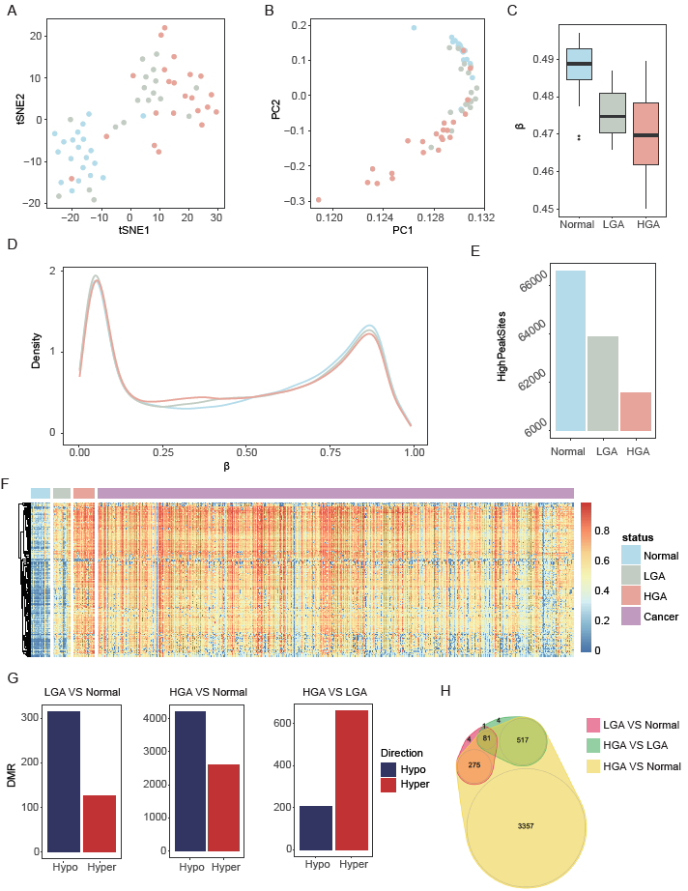

Figure 1. Genome-wide DNA methylation of low-grade adenoma (LGA), high-grade colorectal adenoma (HGA) and normal colorectal tissue. (A): tSNE analysis highlights the data structure and sample relationship among the sample groups. (B): PCA analysis confirms the data structure and sample relationship of the tSNE analysis. (C): Average methylation levels of Normal (N), LGA, and HGA samples. (D): Density plot reveals the distribution of the whole array probes for N, LGA, and HGA samples. (E): Number of sites in β ranging from 0.7 to 0.9. (F): Heatmap of the 209 hyper-methylated DMSs of in-house datasets and samples from 504 public cancer datasets. (G): DMR between LGA and normal tissues, HGA and normal tissue, and HGA and LGA. (H): Venn graph highlights the relationships among all DMRs.

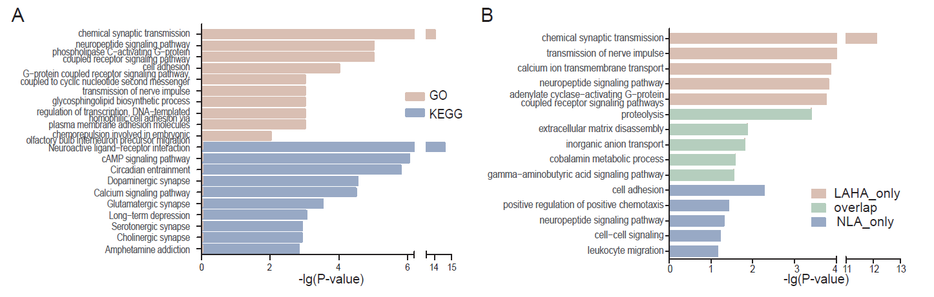

Figure 2. Enrichment analysis shows the top 15-20 terms associated with methylation differences between LGA and HGA. (A) GO and KEGG analysis of the genes with DMRs associated with LGA and HGA. (B) GO analysis of the genes with alterations in DMRs including differences in DMRs only in LGA vs HGA, only in LGA vs Normal, and areas where LGA vs HGA and LGA vs Normal overlapped.

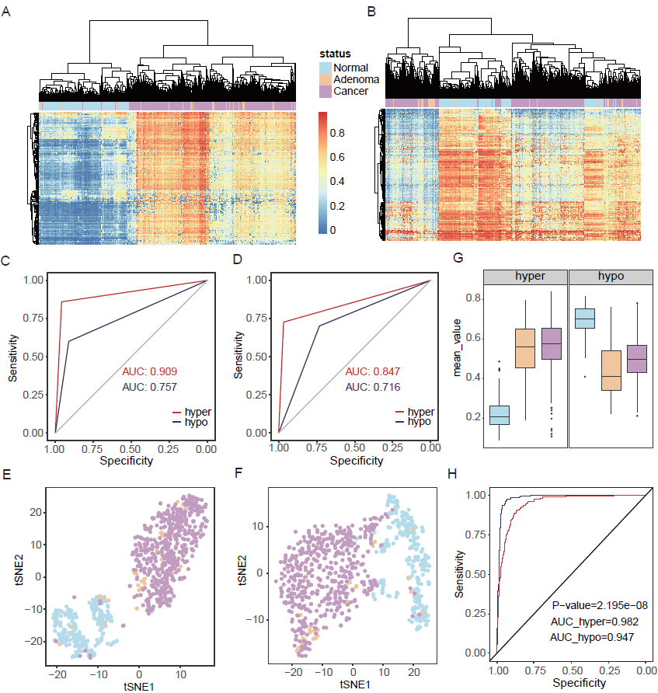

Figure 3. Hyper-methylated CpG sites showed better diagnostic performance than the hypo-methylated pattern. (A): Cluster analysis based on hyper-DMSs among normal, adenoma and cancer samples. (B): Cluster analysis based on hypo-DMSs among normal, adenoma and cancer samples. (C): Random forest prediction performance based on hyper and hypo-DMSs. (D): Neural network prediction performance based on hyper and hypo-DMSs. (E): tSNE analysis highlights the data structure and sample relationship based on hyper-DMSs. (F): tSNE analysis highlights the data structure and sample relationship based on hypo-DMSs. (G): Average methylation level of hyper and hypo-DMSs (H): ROC curve of hyper-mBV and hypo-mBV.

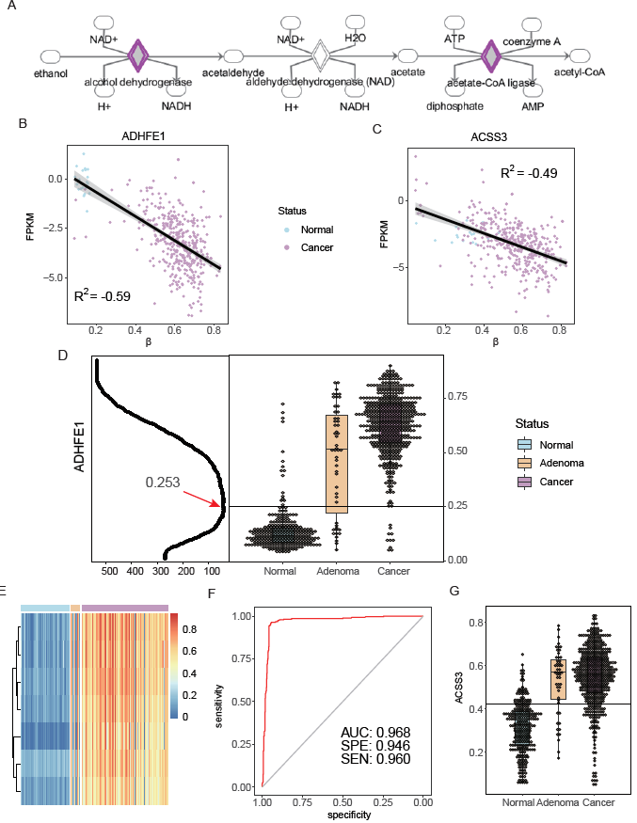

Figure 4. DNA methylation *ADHFE1* and *ACSS3* in Normal, Adenoma, and Cancer. (A): Pathway of ethanol degradation II38. (B): Relationship between DNA methylation and gene expression of *ADHFE1*. (C): Relationship between DNA methylation and gene expression of *ACSS3*. (D): Left panel is identification of cutoff where the X axis is sample number of classification error; Right panel is DNA methylation of *ADHFE1* in normal, adenoma, and cancer samples. (E): Heatmap of sites within *ADHFE1* promoter in normal, adenoma and cancer samples. (F): ROC of the prediction of *ADHFE1* for colorectal adenoma and cancer. (G): DNA methylation of *ACSS3* in normal, adenoma, and cancer samples.

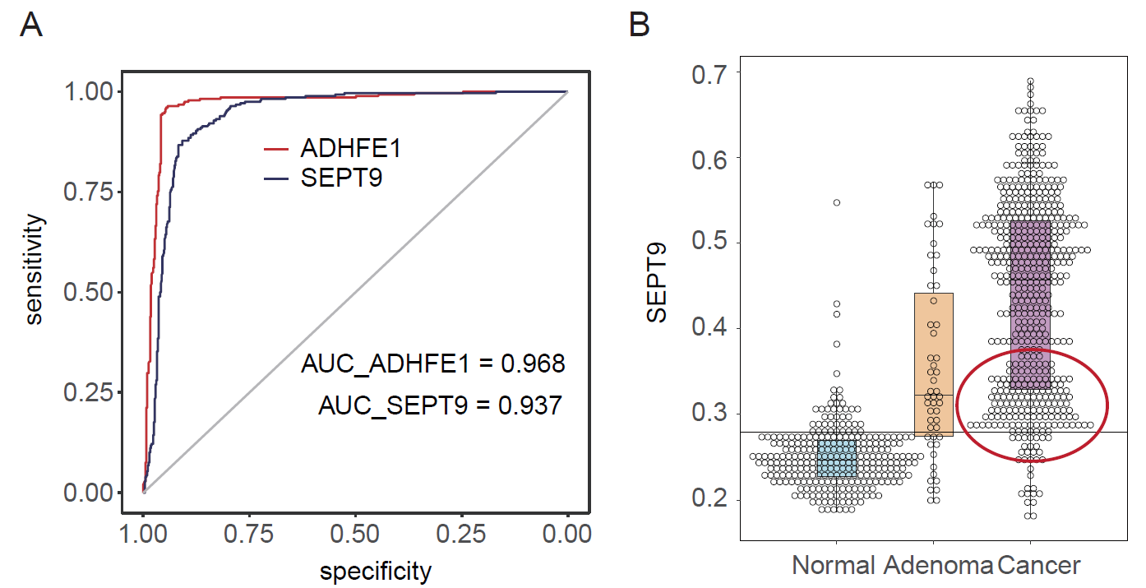

Figure 5. Comparison of *ADHFE1* and *SEPT9.* (A): ROC comparison of *ADHFE1* and *SEPT9*. (B): DNA methylation of *SEPT9* in normal, adenoma, and cancer samples.

Table 1. Prediction performance based on hyper-DMS and hypo-DMS to distinguish between disease and normal colorectal tissues.

|  |  |  |  |  |  |  |
| --- | --- | --- | --- | --- | --- | --- |
| Model | Methylation | Observation | Prediction | | Sensitivity | Specificity |
| Disease | Normal |
| Random Forest | hyper | Disease | 532 | 23 | 0.959 | 0.860 |
| Normal | 39 | 239 |
| hypo | Disease | 507 | 48 | 0.914 | 0.601 |
| Normal | 111 | 167 |
| Neural Network | hyper | Disease | 537 | 18 | 0.968 | 0.727 |
| Normal | 76 | 202 |
| hypo | Disease | 406 | 149 | 0.732 | 0.701 |
| Normal | 83 | 195 |